

**Day 2: Spiritual Awakening in Dwarka**

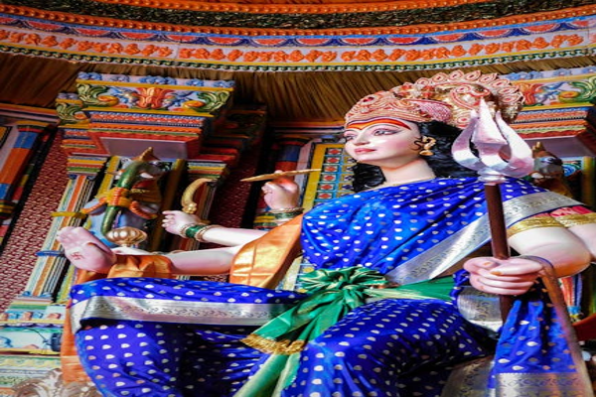

Travel Time: Not Applicable  
Today, we will devote the entire day to exploring the religious sites of Dwarka. We will visit Rukmini Devi Temple, Nageshwar Jyotirlinga Temple, and Bet Dwarka. These sacred sites hold immense significance for Hindu devotees.